News Article

One Voice for Radiotherapy: Creating World Radiotherapy Awareness Day

Katie Wakeham and Sandra Turner, Co-Chairs World Radiotherapy Awareness Day (WRAD) Committee

As radiation oncology professionals, we know that radiotherapy is vital for curing cancer, alleviating symptoms, and improving a patient’s quality of life. Access to radiotherapy is directly linked to improved survival for many cancers. Radiotherapy is also a highly cost-effective cancer treatment. However, around the world, significant regional and national disparities persist. Reasons include inadequate services, geographical barriers, insufficient workforce and a lack of awareness of modern radiotherapy.

One way to overcome these disparities is to create a radiotherapy awareness day to provide a platform for the global radiotherapy community to join together and direct attention to the public, media and governments. Radiotherapy is a crucial treatment modality in oncology, utilized across various age groups, including children, young adults, and older adults, for the management of diverse cancer types.

The first-ever World Radiotherapy Awareness Day (WRAD) will launch on September 7, the date the first patient was treated on a linear accelerator. WRAD’s theme is “One Voice for Radiotherapy”. The launch of the day includes a number of approaches including live and virtual events, social media promotions, print and broadcast announcements and stories in the media.

We announced the concept of World Radiotherapy Awareness Day in November 2024, during London Global Cancer Week. The interest and committed support from the broader radiotherapy community was overwhelming. A planning meeting was then held in March 2025 where the WRAD date, logo, theme and campaign messages were announced. The planning events were both in-person and virtual and also recorded to ensure true global participation. We had over 800 registrants from around the world at the two meetings, a testament to the enthusiasm for the WRAD initiative.

An array of Radiotherapy societies from around the world, including ALATRO, AORTIC, ASTRO, CACA, CARO, ESTRO, FARO, MESTRO, PROS, RCR, SIOP, radiotherapy professionals and patient advocates have joined the WRAD movement and are planning ways they can get involved and raise more awareness about radiotherapy.

The WRAD website, social media channels and resources for participants have recently been launched and we encourage supporters to visit the WRAD site and access these resources. To stay connected with the WRAD movement year round, follow the WRAD events page to see where WRAD will be promoted and featured at major oncology conferences.

We ask you to please show your support for this important initiative and get involved by:
- Following WRAD on social media
- Reposting and creating messages around “One Voice for Radiotherapy” on your social media channels
- Sign up to the WRAD newsletter via the website
- Create a WRAD event using resources in the WRAD website with your team to celebrate the launch of WRAD

We believe that WRAD’s global reach and inclusive approach position it as a unifying movement to champion the life-saving and life-improving potential of radiotherapy. Please join us!

Social Media: X LinkedIn YouTube Facebook
Use the hashtags: #WorldRTDay #WRAD #OneVoiceForRadiotherapy

Acknowledgement: The founding WRAD Committee members are Katie Wakeham, Sandra Turner, Michelle Leech, Lucinda Morris, Darien Laird and Sarah Quinlan. The WRAD Committee operates with the Global Coalition for Radiotherapy.

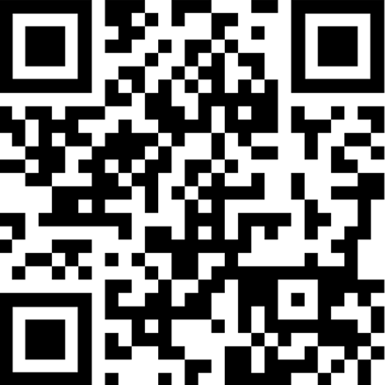
https://www.worldradiotherapy.org/

